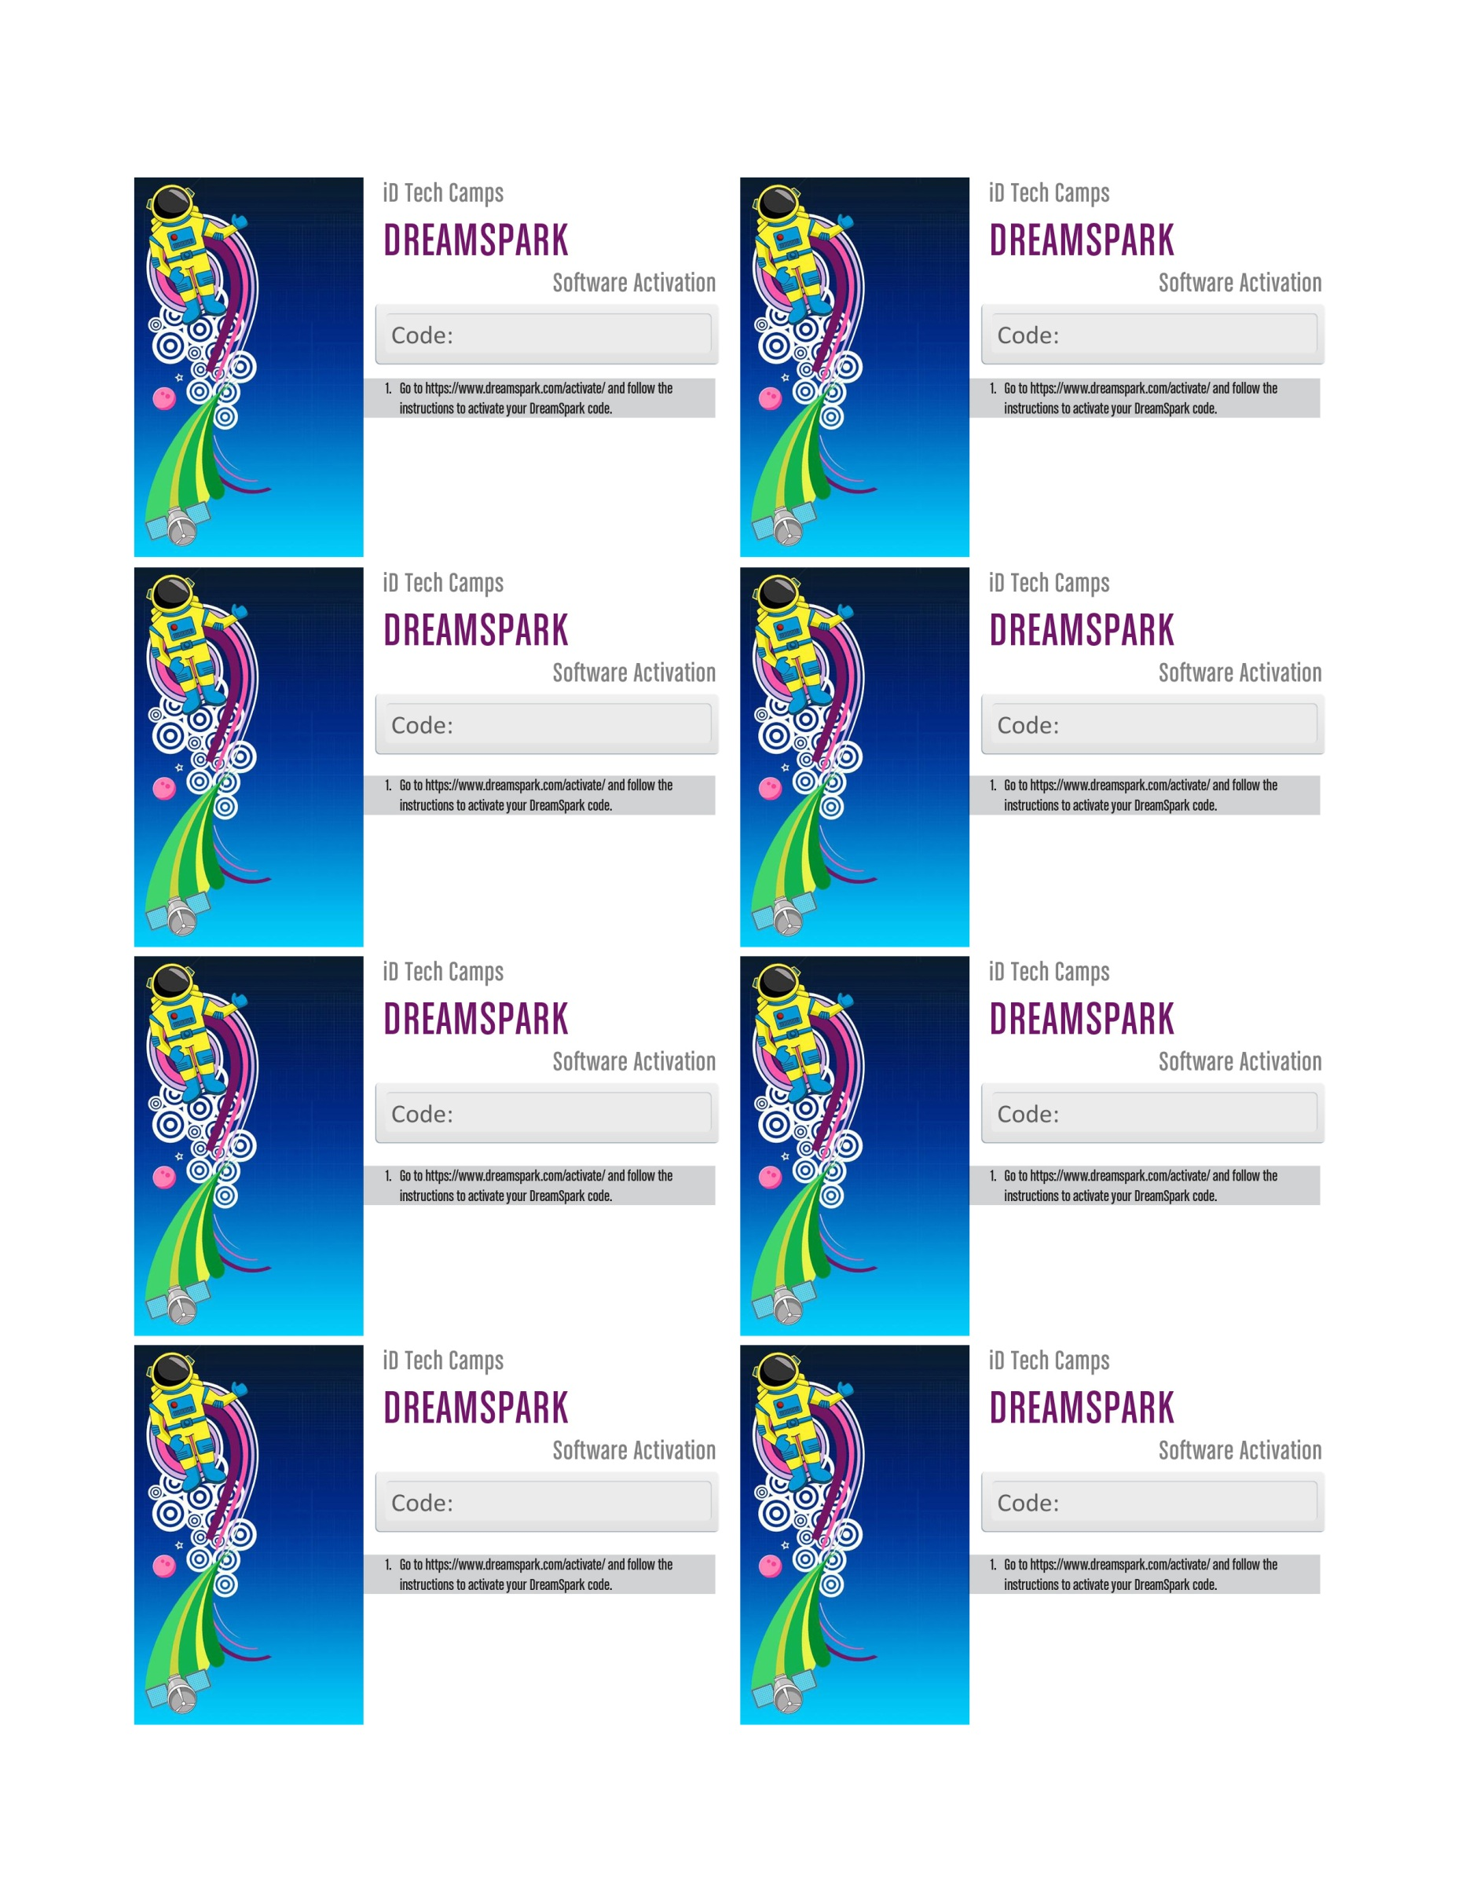

**12345678910111213**

**12345678910111213**

**12345678910111213**

**12345678910111213**

**12345678910111213**

**12345678910111213**

**12345678910111213**

**12345678910111213**